Social and Professional Issues

Tutorial 7

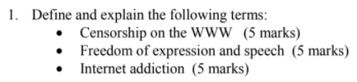

* Censorship on the WWW is the control or suppression of what can be accessed, published or viewed on the internet/website enacted by regulators or responsible authorities. For example, Malaysia government has censored racism content on social media to prevent argument among citizens from happening which will also affect the harmony of the citizens.
* Freedom of expression and speech is recognized as a human right where everyone has the right to hold opinions and to receive and impart information and ideas without interference by public authorities and regardless of frontiers. For example, everyone has their own perspective and each of us can state our opinion on something whether the opinion itself is good or bad.
* Internet addiction is characterized by excessive poorly controlled preoccupations, urges or behaviors regarding computer use and internet access that lead to impairment or distress. Some forms of internet addiction are online gaming addiction or online gambling addiction.

|  |
| --- |
| Sample answer |

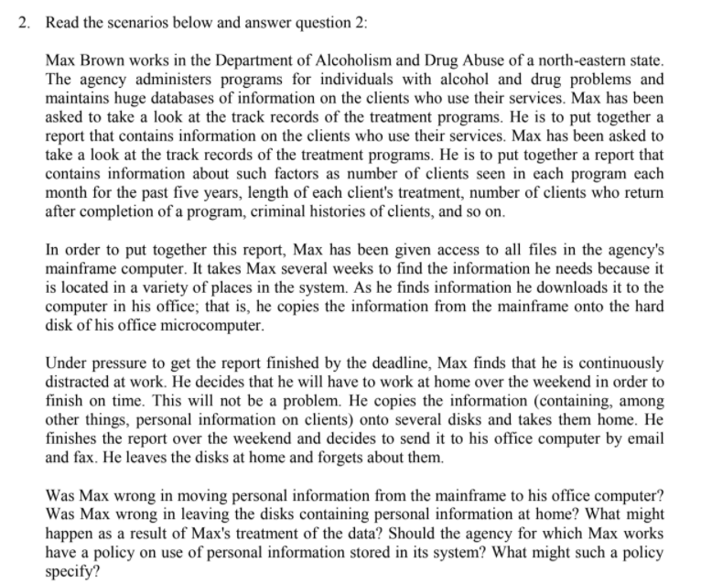



**Opting in** means the consumer must explicitly give permission before the organization can share info. The most common way we see opt-in methods implemented is through checkboxes. When presented with a checkbox, the user must take action to check the box, which denotes their consent.

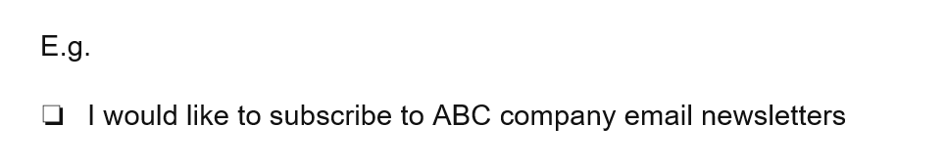

**Opting out** means the organization can share info until consumers explicitly forbid it. The way to offer opt-outs to users is a pre-emptive opt-out, in which users can uncheck a marked box or otherwise undo a confirmation in order to indicate that they are not interested in the activity you’re presenting to them.

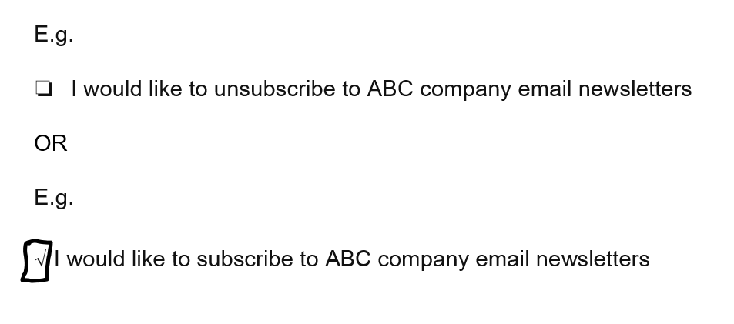

|  |
| --- |
| Sample Answer |



Organizations can collect personal information about customers, employees and partners to perform **business analysis and marketing** which can bring benefits to the organizations. This means the organizations have an obligation to protect that information. Failure to do so could lead to legal issues or even bankruptcy.

Example of the uses of personal information:

|  |  |
| --- | --- |
| **Private organizations** | **Public organizations** |
| * Credit card purchases * Purchases made with loyalty cards | * motor vehicle records * criminal record |

|  |
| --- |
| Sample Answer |



Personal Data Protection Act 2021 as known as “PDPA”. The Act is to regulate the processing of personal data in commercial transactions (Ie: Banking, Investment, Trading, Insurance) and to provide for matters connected therewith and incidental thereto. Also, the PDPA prohibits data users from collecting and processing a data subject's personal data without his or her consent and prohibits data users from disclosing or making its data available to any third party without the consent of data subjects. This Act applies to any person who processes; and any person who has control over or authorizes the processing of, any personal data in respect of commercial transactions. The penalty for non-compliance is between RM100k to 500k and/or between 1 to 3 years imprisonment.

The PDPA consists of 7 main principles:

general principle notice and choice principle, disclosure principle, security principle, retention principle, data integrity principle and lastly is access principle.

|  |
| --- |
| Sample Answer |



i) **Establish clear rules for data management of citizens from organizations.** A widely accepted and understood legal framework ensures that citizens are able to live at ease knowing their privacy is protected and that violations of such expectations can be publicly acknowledged to hold organizations accountable.

E.g. Privacy Disclaimer that declare rule & scope of data access & security measure taken by merchant to protect customer

ii) **Apply the latest data protection approaches.** The best of data protection should include removing personally identifiable information from data, limiting access to sensitive data from only secure centers, and exploring new technologies.

E.g. Antivirus software, antispyware

i) Do not share personal information via word of mouth or any other means of communication.

ii) Do not post personal photos in public websites

iii) Do not simply post any information on any websites before observing the website’s privacy / personal data usage policy.

iv) Do not reply to spamming websites regardless of the reason

|  |
| --- |
| Sample Answer |



|  |  |  |
| --- | --- | --- |
|  | **Personal information rights** | **Intellectual property rights** |
| **Definition** | Personal information is essentially any information that identifies a person. It refers to any factual or subjective information, whether recorded or not, about an identifiable individual. | Intellectual property (IP) refers to any unique product of the human intellect that has commercial value. Types of intellectual property are patents, copyrights, franchises, trade secrets. |
| **Examples** | A person’s name, signature, home address, email address, telephone number, date of birth, medical records, bank account details and employment details will generally constitute personal information. | Books, songs, movies, paintings, drawings, inventions, chemical formulas, computer programs, trade /food recipe. |
| **Protection imposed** | Privacy protection -e.g. Personal data protection act 2010 | Copyright protection, patent protection, trademark protection, trade recipe protection... |

|  |
| --- |
| Sample Answer |